1. Given X be a discrete random variable with the following PMF

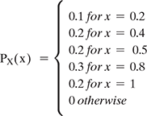

Find the range RX of the random variable X.

Find P(X ≤ 0.5)

Find P(0.25<X<0.75)

P(X = 0.2|X<0.6)

Ans : A.The range of X can be found from the PMF. The range of X consists of possible values for X. Here we have

RX={0.2,0.4,0.5,0.8,1}.

B.The event X≤0.5 can happen only if X is 0.2,0.4, or 0.5. Thus,

P(X≤0.5) =P(X∈{0.2,0.4,0.5})

=P(X=0.2)+P(X=0.4)+P(X=0.5)

=PX(0.2)+PX(0.4)+PX(0.5)

=0.1+0.2+0.2=0.5

C.Similarly, we have

P(0.25<X<0.75) =P(X∈{0.4,0.5})

=P(X=0.4)+P(X=0.5)

=PX(0.4)+PX(0.5)

=0.2+0.2=0.4

D.This is a conditional probability problem, so we can use our famous formula P(A|B)=P(A∩B)P(B). We have

P(X=0.2|X<0.6) =P((X=0.2) and (X<0.6))P(X<0.6)

=P(X=0.2)P(X<0.6)

=PX(0.2)PX(0.2)+PX(0.4)+PX(0.5)

=0.10.1+0.2+0.2=0.2

2.Two equal and fair dice are rolled, and we observed two numbers X and Y.

Find RX, RY, and the PMFs of X and Y.

Find P(X = 2,Y = 6).

Find P(X>3|Y = 2).

If Z = X + Y. Find the range and PMF of Z.

Find P(X = 4|Z = 8).

Ans : We have RX=RY={1,2,3,4,5,6}. Assuming the dice are fair, all values are equally likely so

Px(k) = {⅙ for k =1,2,3,4,5,6

0 Otherwise

Similarly for Y,

PY(k)={⅙

0 for k=1,2,3,4,5,6otherwise

Since X and Y are independent random variables, we can write

P(X=2,Y=6) =P(X=2)P(Y=6)

=1/6⋅1/6=1/36.

Since X and Y are independent, knowing the value of Y does not impact the probabilities for X,

P(X>3|Y=2) =P(X>3)

=PX(4)+PX(5)+PX(6)

=1/6+1/6+1/6=1/2.

First, we have RZ={2,3,4,...,12}. Thus, we need to find PZ(k) for k=2,3,...,12. We have

PZ(2) =P(Z=2)=P(X=1,Y=1)

=P(X=1)P(Y=1) (since X and Y are independent)

=1/6⋅1/6=1/36;

PZ(3) =P(Z=3)=P(X=1,Y=2)+P(X=2,Y=1)

=P(X=1)P(Y=2)+P(X=2)P(Y=1)

=1/6⋅1/6+1/6⋅1/6=1/18;

PZ(4) =P(Z=4)=P(X=1,Y=3)+P(X=2,Y=2)+P(X=3,Y=1)

=3⋅1/36=1/12.

We can continue similarly:

PZ(5) =4/36=1/9;

PZ(6) =5/36;

PZ(7) =6/36=1/6;

PZ(8) =5/36;

PZ(9) =4/36=1/9;

PZ(10) =3/36=1/12;

PZ(11) =2/36=1/18;

PZ(12) =1/36.

It is always a good idea to check our answers by verifying that ∑z∈RZPZ(z)=1. Here, we have

∑z∈RZPZ(z) =1/36+2/36+3/36+4/36+5/36+6/36

+5/36+4/36+3/36+2/36+1/36

=1.

Note that here we cannot argue that X and Z are independent. Indeed, Z seems to completely depend on X, Z=X+Y. To find the conditional probability P(X=4|Z=8), we use the formula for conditional probability

P(X=4|Z=8) =P(X=4,Z=8)P(Z=8)

=P(X=4,Y=4)P(Z=8)

=P(X=4)P(Y=4)P(Z=8) (since X and Y are independent)

⅙.1/6/5/36

=15.

3. In an exam, there were 20 multiple-choice questions. Each question had 44 possible options. A student knew the answer to 10 questions, but the other 10 questions were unknown to him, and he chose answers randomly. If the student X's score is equal to the total number of correct answers, then find out the PMF of X. What is P(X>15)?

Ans : Let's define the random variable Y as the number of your correct answers to the 10 questions you answer randomly. Then your total score will be X=Y+10. First, let's find the PMF of Y. For each question your success probability is 14. Hence, you perform 10 independent Bernoulli(14) trials and Y is the number of successes. Thus, we conclude Y∼Binomial(10,14), so

PY(y)={(10y)(14)y(34)10−y0for y=0,1,2,3,...,10otherwise

Now we need to find the PMF of X=Y+10. First note that RX={10,11,12,...,20}. We can write

PX(10) =P(X=10)=P(Y+10=10)

=P(Y=0)=(100)(14)0(34)10−0=(34)10;

PX(11) =P(X=11)=P(Y+10=11)

=P(Y=1)=(101)(14)1(34)10−1=10(14)(34)9.

So, you get the idea. In general for k∈RX={10,11,12,...,20},

PX(k) =P(X=k)=P(Y+10=k)

=P(Y=k−10)=(10k−10)(14)k−10(34)20−k.

To summarize,

PX(k)={(10k−10)(14)k−10(34)20−k0for k=10,11,12,...,20 otherwise

In order to calculate P(X>15), we know we should consider y=6,7,8,9,10

In order to calculate P(X>15), we know we should consider y=6,7,8,9,10

P(X>15)=PX(16)+PX(17)+PX(18)+PX(19)+PX(20)=(106)(14)6(34)4+(107)(14)7(34)3+(108)(14)8(34)2+(109)(14)9(34)1+(1010)(14)10(34)0.

4. The number of students arriving at a college between a time interval is a Poisson random variable. On average, 10 students arrive per hour. Let Y be the number of students arriving from 10 am to 11:30 am. What is P(10<Y≤15)?

Ans : We are looking at an interval of length 1.5 hours, so the number of customers in this interval is X∼Poisson(λ=1.5×10=15). Thus,

P(10<X≤15) =∑15k=11PX(k)

=∑15k=11e−1515kk!

=e−15[151111!+151212!+151313!+151414!+151515!]

=0.4496

5.Two independent random variables, X and Y,are given such that X~Poisson(α) and Y~Poisson(β). State a new random variable as Z = X + Y. Find out the PMF of Z.

Ans : First note that since RX={0,1,2,..} and RY={0,1,2,..}, we can write RZ={0,1,2,..}. We have

PZ(k) =P(X+Y=k)

=∑ki=0P(X+Y=k|X=i)P(X=i) (law of total probability)

=∑ki=0P(Y=k−i|X=i)P(X=i)

=∑ki=0P(Y=k−i)P(X=i) (since X and Y are independent)

=∑ki=0e−ββk−i(k−i)!e−ααii!

=e−(α+β)∑ki=0αiβk−i(k−i)!i!

=e−(α+β)k!∑ki=0k!(k−i)!i!αiβk−i

=e−(α+β)k!∑ki=0(ki)αiβk−i

=e−(α+β)k!(α+β)k (by the binomial theorem).

Thus, we conclude that Z∼Poisson(α+β).

6. There is a discrete random variable X with the pmf.

image.png If we define a new random variable Y = (X + 1)2 then

Find the range of Y.

Find the pmf of Y.

2.Assuming X is a continuous random variable with PDF

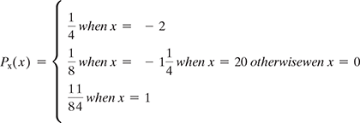

Find EX and Var(X).

Find P(X ≥ 1/2).

If X is a continuous random variable with pdf 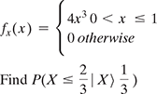

If X~Uniform and Y = sin(X), then find fY(y).

If X is a random variable with CDF

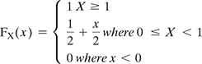

What kind of random variable is X: discrete, continuous, or mixed?

Find the PDF of X, fX(x).

Find E(eX).

Find P(X = 0|X≤0.5).

Ans : Here, the random variable Y is a function of the random variable X. This means that we perform the random experiment and obtain X=x, and then the value of Y is determined as Y=(x+1)2. Since X is a random variable, Y is also a random variable.

To find RY, we note that RX={−2,−1,0,1,2}, and

RY ={y=(x+1)2|x∈RX}

={0,1,4,9}.

Now that we have found RY={0,1,4,9}, to find the PMF of Y we need to find PY(0),PY(1),PY(4), and PY(9):

PY(0) =P(Y=0)=P((X+1)2=0)

=P(X=−1)=18;

PY(1) =P(Y=1)=P((X+1)2=1)

=P((X=−2) or (X=0));

PX(−2)+PX(0)=14+18=38;

PY(4) =P(Y=4)=P((X+1)2=4)

=P(X=1)=14;

PY(9) =P(Y=9)=P((X+1)2=9)

=P(X=2)=14.

Again, it is always a good idea to check that ∑y∈RYPY(y)=1. We have

∑y∈RYPY(y)=18+38+14+14=1.

5. There are two random variables X and Y with joint PMF given in Table below

Find P(X≤2, Y≤4).

Find the marginal PMFs of X and Y.

Find P(Y = 2|X = 1).

Are X and Y independent?

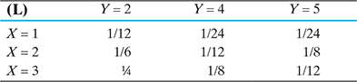

Ans : To find P(X≤2,Y≤4), we can write

P(X≤2,Y≤4)=PXY(1,2)+PXY(1,4)+PXY(2,2)+PXY(2,4)=112+124+16+112=38.

Note from the table that

RX={1,2,3} and RY={2,4,5}.

Now we can use Equation 5.1 to find the marginal PMFs:

PX(x)=⎧⎩⎨⎪⎪⎪⎪⎪⎪⎪⎪⎪⎪⎪⎪⎪⎪⎪⎪⎪⎪⎪⎪⎪⎪⎪⎪⎪⎪163811240x=1x=2x=3otherwise

PY(y)=⎧⎩⎨⎪⎪⎪⎪⎪⎪⎪⎪⎪⎪⎪⎪⎪⎪⎪⎪⎪⎪⎪⎪⎪⎪⎪⎪⎪⎪1214140y=2y=4y=5otherwise

Using the formula for conditional probability, we have

P(Y=2|X=1)=P(X=1,Y=2)P(X=1)=PXY(1,2)PX(1)=11216=12.

Are X and Y independent? To check whether X and Y are independent, we need to check that P(X=xi,Y=yj)=P(X=xi)P(Y=yj), for all xi∈RX and all yj∈RY. Looking at the table and the results from previous parts, we find

P(X=2,Y=2)=16≠P(X=2)P(Y=2)=316.

Thus, we conclude that X and Y are not independent.

6.A box containing 40 white shirts and 60 black shirts. If we choose 10 shirts (without replacement) at random, find the joint PMF of X and Y, where X is the number of white shirts and Y is the number of black shirts.

7.If A and B are two jointly continuous random variables with joint PDF



Find fX(a) and fY(b).

Are A and B independent of each other?

Find the conditional PDF of A given B = b, fA|B(a|b).

Find E[A|B = b], for 0 ≤ y ≤ 1.

Find Var(A|B = b), for 0 ≤ y ≤ 1.

Ans : 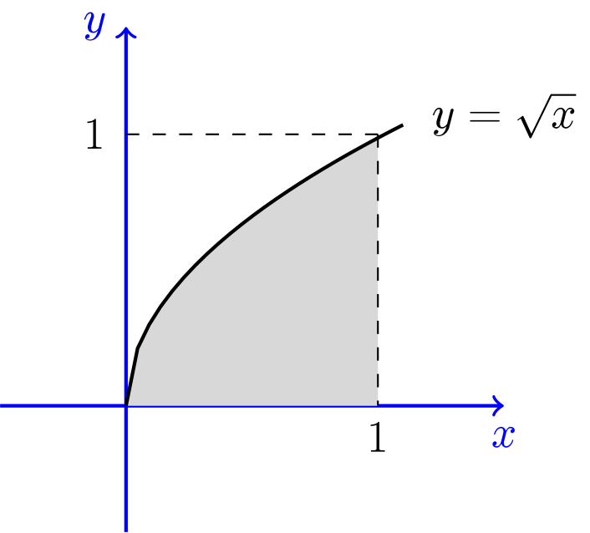

First, note that RX=RY=[0,1]. To find fX(x) for 0≤x≤1, we can write

fX(x)=∫∞−∞fXY(x,y)dy=∫x√06xydy=3x2.

Thus,

fX(x)=⎧⎩⎨⎪⎪3x200≤x≤1otherwise

To find fY(y) for 0≤y≤1, we can write

fY(y)=∫∞−∞fXY(x,y)dx=∫1y26xydx=3y(1−y4).

fY(y)=⎧⎩⎨⎪⎪3y(1−y4)00≤y≤1otherwise

X and Y are not independent, since fXY(x,y)≠fx(x)fY(y).

We have

fX|Y(x|y)=fXY(x,y)fY(y)=⎧⎩⎨⎪⎪⎪⎪2x1−y40y2≤x≤1otherwise

We have

E[X|Y=y]=∫∞−∞xfX|Y(x|y)dx=∫1y2x2x1−y4dx=2(1−y6)3(1−y4).

We have

E[X2|Y=y]=∫∞−∞x2fX|Y(x|y)dx=∫1y2x22x1−y4dx=1−y82(1−y4).

Thus,

Var(X|Y=y)=E[X2|Y=y]−(E[X|Y=y])2=1−y82(1−y4)−(2(1−y6)3(1−y4))2.

8.There are 100 men on a ship. If Xi is the ith man's weight on the ship and Xi's are independent and identically distributed and EXi = μ = 170 and σX = σ = 30. Find the probability that the men's total weight on the ship exceeds 18,000.

Ans : If W is the total weight, then W=X1+X2+⋯+Xn, where n=100. We have

EWVar(W)=nμ=(100)(170)=17000,=100Var(Xi)=(100)(30)2=90000.

Thus, σW=300. We have

P(W>18000)=P(W−17000300>18000−17000300)=P(W−17000300>103)=1−Φ(103)(by CLT)≈4.3×10−4.

9.Let X1, X2, ……, X25 are independent and identically distributed. And have the following PMF. If Y = X1 + X2 + … + Xn, estimate P(4 ≤ Y ≤ 6) using central limit theorem.

Ans : We have

EXi=(0.6)(1)+(0.4)(−1)=15,

EX2i=0.6+0.4=1.

Therefore,

Var(Xi)thus,σXi=1−125=2425;=26–√5.

Therefore,

EY=25×15=5,

Var(Y)thus,σY=25×2425=24;=26–√.

P(4≤Y≤6)=P(3.5≤Y≤6.5)(continuity correction)=P(3.5−526–√≤Y−526–√≤6.5−526–√)=P(−0.3062≤Y−526–√≤+0.3062)≈Φ(0.3062)−Φ(−0.3062)(by the CLT)=2Φ(0.3062)−1≈0.2405